TC-CMS-035
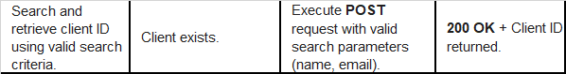
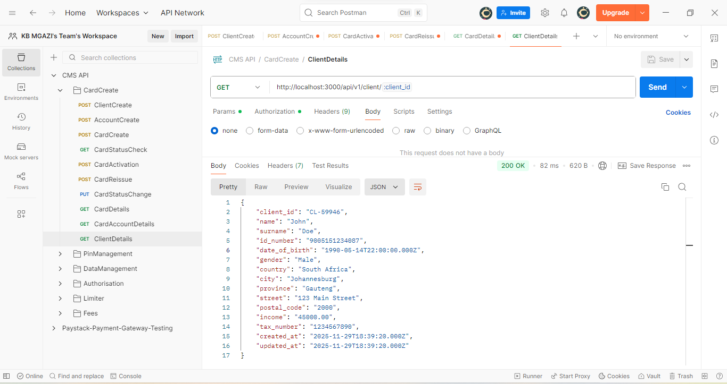
Response:
{
"client_id": "CL-59946",
"name": "John",
"surname": "Doe",
"id_number": "9005151234087",
"date_of_birth": "1990-05-14T22:00:00.000Z",
"gender": "Male",
"country": "South Africa",
"city": "Johannesburg",
"province": "Gauteng",
"street": "123 Main Street",
"postal_code": "2000",
"income": "45000.00",
"tax_number": "1234567890",
"created_at": "2025-11-29T18:39:20.000Z",
"updated_at": "2025-11-29T18:39:20.000Z"
}

